SuccessFactors Pay Statement Quick Reference Guide

Last Updated: 9/8/2022
Contents
Accessing the Pay Statement 1
Reading the Pay Statment 3

This QRG outlines the content and layout of an employee pay statement in SuccessFactors.
Questions regarding benefit deductions including retirement should be directed to hr@purdue.edu or 765-494-2222 or to the regional campus HR Department. Questions regarding time should be directed to: Purdue West Lafayette – timeadmin@purdue.edu, Purdue Fort Wayne – payroll@pfw.edu, Purdue Northwest – pnw-payroll@pnw.edu.

Accessing the Pay Statement
From the SuccessFactors home page, under the Organizational Updates – Additional Actions, click the Pay Statements 1/1/2019 to Present tile.

Reading the Pay Statment
Terminology/Abbreviations | ER = Employer  EE = Employee  TX = Tax
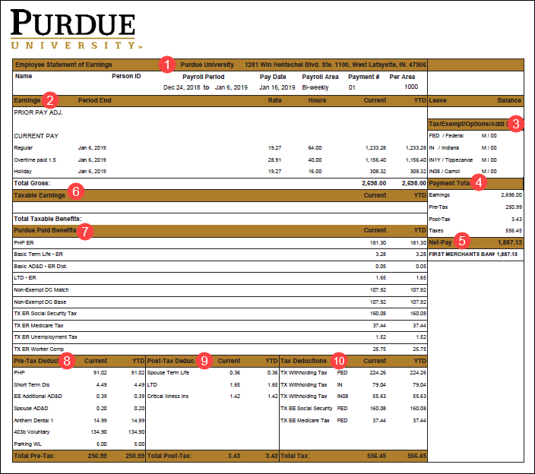
Section | Description
- Pay Statement Header | The Payroll Period and Pay Date for the currently displayed Pay Statement.
- Earnings | Earnings for the selected period, including worked time, vacation, holiday, sick, etc.
- Tax Exemptions | Total number of tax exemptions or additional funds withheld.
- Payment Total | Total earnings, minus deductions and taxes, resulting in net-pay deposited.
- Net Pay | Total amount deposited into selected financial institution(s).
- Taxable Earnings | Imputed Income for the Group Term Life Insurance.
- Purdue Paid Benefits | Benefits paid by Purdue such as Taxes, Health Insurance, Basic Term Life Insurance, AD&D, Long Term Disability (LTD), Health Savings Account (HSA), and Retirement.
- Pre-Tax Deductions | Deductions taken before taxes which include medical, dental, Health Savings Account (HSA), Flexible Spending Account (FSA), Limited Purpose Flexible Spending Account (LPFSA), Dependent Care Flexible Spending Account (DCFSA), AD&D, Short Term Disability, and Retirement.
- Post-Tax Deductions | Deductions taken after taxes which include Long Term Disability (LTD), United Way, Giving to Purdue, Voluntary Benefits (Legal, Critical Illness, Supplemental Hospital, Accident Insurance, and Universal Life).
- Tax Deductions | Tax amount withheld which include State and Federal Taxes, Social Security, and Medicare.

